INSTITUTE OF MICROBIAL TECHNOLOGY (IMTECH),
(Council of Scientific & Industrial Research)
Sector 39-A, Chandigarh -160036 (India)

Ph: 0091-172-2690056/2695225/6/7 ext. 331/334, fax:2 690585/2690632, 2636683

e-mail: purchase@imtech.res.in
Top of Form

No: PUR/2013-14/IND30282/KK | Date: 19/02/2014

Sub : Request for Pro-forma Invoice
Dear Sir
This Research Institute is interested in purchasing of the items mentioned below. You are therefore requested to forward a pro-forma invoice along with your terms & conditions of supply & payment. Please provide a copy of the technical literature and the specifications of these items in a sealed envelope.
Please read carefully the terms and conditions mentioned overleaf and submit your pro-forma invoice/quotation accordingly.

SNo. | Name of Item | Catalog No | Qty
1 | Protein Purification System, 1 |  | 1
Important
- Please mention our reference number on the envelop and address all correspondence to Director IMT Chandigarh only.
- Please quote strictly as per our specifications.
- Please attach compliance sheet
- Proforma Invoice received after due date will not be considered under any circumstances.
- Please note that your Quotation should reach us on 03/03/2014 at 12.00 Noon opened on 3/03/2014 at 3.30 p.m.
- Your Quotation must be duly stamped and reach directly to IMT from you only. If quotation is submitted by Indian representative/agent then they must have to produce a authority certificate of principal party for quotating the price Other wise it will be very difficult at our end to consider your quotation.

Yours faithfully,
Stores & Purchase Officer.

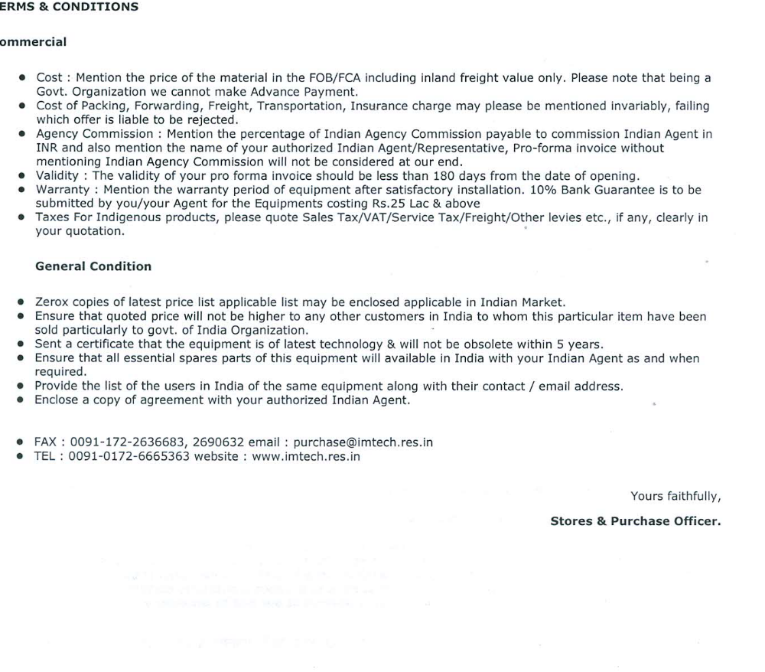Bottom of Form

Specifications:
Protein Purification System – Multi wavelength detection and Fraction Collector
- Automatic, Bio-compatible, Integrated and Computer Controlled Protein Purification System with latest Control and Evaluation software.
- Pump:
  - Binary gradient pump.
  - Flow rate: 0.002-20ml/min or better; increment of 0.001 ml or better. Flow rate should cover the entire gradient and should not be isocratic only.
- UV Monitor with
  - Detect three or more wavelengths at a time in the entire wavelength range of 190-700. nm (or wider range) simultaneously without the change of lamp.
  - Ability to detect at least within absorbance range from -4 to +4 Au.
  - Ability to automatically turn off lamp after completion of the run method.
- Online gradient mixer for buffer gradient formation.
- Conductivity Monitor:
  - Conductivity reading range 10µS-999 µS/cm or better.
- Fraction collector:

- pH Stability range: 1 to 13 or better.
- Fraction Size: 0.1 to 250 ml in Volume mode and Time mode – with Drop Synchronization and Software controlled Accumulator. While moving from one tube to other, the fraction collector should have the ability to accumulate and hold the eluted volume, and dispense accumulated volume in next tube.
- Capable of collecting fractions in 1.5ml microtube, tubes (12-13mm, 15-16mm and 18-20 mm diameter) and 24, 48, 96 well format microplates (up to 4 or more). All Accessories including cassettes for collecting fractions in 1.5ml microtube and 24, 48 and 96 well format must be supplied.
- Flow Diversion Valve: For waste diversion from flow path to waste.
- Sample loops to be supplied: 200-250uL, 500uL, 1 ml, 2ml, 5 ml (two numbers each).
- Software should perform Real Time Control and Data Evaluation, Method Wizard for easy programming, Column Library, with Report generation option.
- OEM computer with Intel i7 based processor, 8GB RAM, 1 TB hard disk, 21'' TFT Screen, keyboard and mouse with latest compatible operating System (Preferably Windows XP if compatible with FPLC software).
- Laser Network Printer must be supplied.
- All the accessories including PEEK Tubing, ferrules and unions/connectors required to run the above should be supplied.
- 2 in-line filters should be supplied.
- System should be supplied with at least 1 years of warranty.
- Vendor should not quote a product which will be discontinued in next five years.
- Vendor should provide Purchase Order(s) of the quoted products sold to Indian Institutions.
- Vendor must ensure that any upgrade in the software or its features will be provided to us free of cost during the warranty period of the instrument.
Optional items:
- Optional racks for Fraction collector.
- Two in-line and/or external air sensors.
- In-line pH monitoring system.
- I/O box for integrating third party detector.
- Additional 2 years of comprehensive warranty.

