INSTITUTE OF MICROBIAL TECHNOLOGY (IMTECH)
(Council of Scientific & Industrial Research)
Sector 39-A, Chandigarh – 160036 (India)

Phone: 0091-172-2690056/2636680-85. Ext. 363 Fax: 2690585/2636683
E.mail: purchase@imtech.res.in

EXPRESSION OF INTEREST

(Advt. No. Pur-74/2015-16)

The Director CSIR-IMTECH intend to procure various equipments. Interested participants/reputed Indian/foreign manufacturers and authorized dealers may attend pre-indent conference at GNRPC Conference Room (Gr. Floor), IMTECH along with technical proposals presentation and demonstration as schedule below:-

- Bioanalyzer, Equipment for Cell density and Cell viability measurement & Lyophilizer (Freeze Dryer) System at 2.30 p.m. on 16.11.2015.

- Isothermal Titration Calorimetry and Differential Scanning Calorimetry at 10.30 a.m. on 18.11.2015.

For details visit our website: "http://www.imtech.res.in.

Contd…..
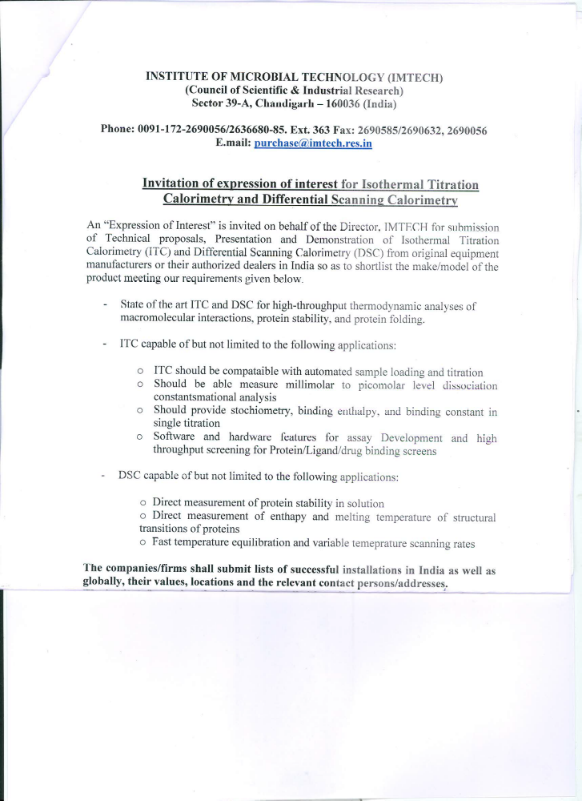

INSTITUTE OF MICROBIAL TECHNOLOGY (IMTECH)
(Council of Scientific & Industrial Research)
Sector 39-A, Chandigarh – 160036 (India)

Phone: 0091-172-2690056/2636680-85. Ext. 363 Fax: 2690585/2636683
E.mail: purchase@imtech.res.in

EXPRESSION OF INTEREST

- Bioanalyzer:

The same instrument to have capability for measuring pH, pO2, pCO2, Na, K, glucose, glutamate, glutamine, glycerol, lactate, ammonium, osmolarity etc. from a single sample. The equipment should have the capability to attach online auto sampler for connecting to bioreactors or fermentation vessels and provided with data management and communication software.

- Equipment for cell density and cell viability measurement:

An equipment system to automate the trypan blue exclusion method (including sample aspiration, dilution, mixing, staining, cell classification and data management) for application in mammalian cell viability and cell density studies, provided with a high resolution vision system with precise and quality image capture on a single, mono-layer of cells within the counting chamber.

- Lyophilizer (Freeze Dryer) systems:

(i) Bench top lyophilizer (Freeze Dryer) system with construction of the unit to comply with freeze drying of biological materials including microbial and cell culture based therapeutic proteins (2.5 -4.0 L) with stoppering tray dryer, with capability to pre-freeze samples in containers or bulk minimum up to 75^{O}C, with communication port to record different parameters.
(ii) A lyophilizer (Freeze Dryer) system with construction of the unit to comply with freeze drying of biological materials including microbial and cell culture based therapeutic proteins with minimum holding capacity of 12 L of ice before defrosting and minimum drying rate of 12 Kg/24 h, having capability to pre-freeze samples in containers or bulk minimum up to -40^{O}C, with communication port to record different parameters.

