H P L C
High-performance liquid chromatography (HPLC) is widely used in diverse fields such as pharmaceuticals, and biochemistry to chemistry, the environment, and food products.
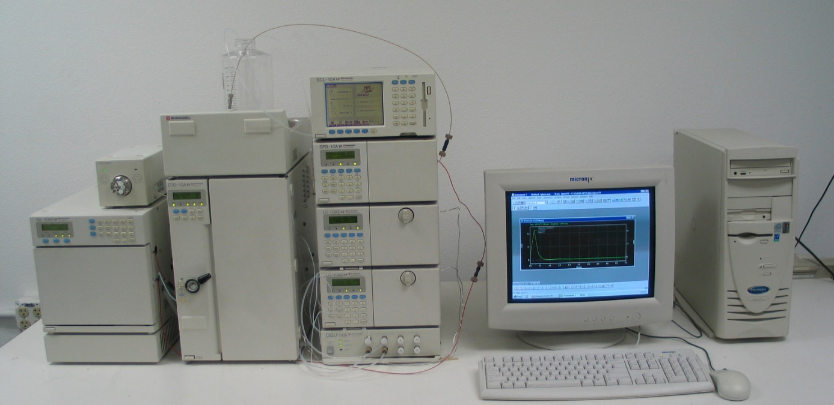
Our HPLC systems are equipped with UV-visible, fluorescence and photo diode array (PDA), detectors. The system has a multitude of set-ups and combination and is capable of delivering both isocratic and gradient solvent elution with various flow rates. A wide range of separations are performed on the instrument, encompassing both normal and reverse phase conditions; with a wide variety of column chemistries utilised for purification, quantitative analysis, fractionation, and separation.
SPECIFICATIONS:
Solvent Delivery Unit: LC-20AD offers superb micro-volume pumping performance
The LC-20AD offers the fast solvent delivery performance. With an automatic pulsation-correction mechanism and high speed micro plunger driving, it achieves pulse-free solvent delivery.
LC-20AD (228-45000-XX)
Solvent delivery method | Parallel-type double plunger
Plunger capacity | 10 μL
Maximum discharge pressure | 40 MPa
Flow-rate setting range | 0.0001 mL/min to 10.0000 mL/min
Flow-rate accuracy | No more than ±1% or ±2 μL/min, whichever is greater (0.01 mL/min to 2 mL/min)
Flow-rate precision | No more than 0.06% RSD or 0.02 min SD, whichever is greater
Typical pulsation | 0.03 MPa (for water at 1.0 mL/min, and 7 MPa)
Gradient type | High-pressure mixing/low-pressure mixing
Mixing-concentration precision | 0.1% RSD max.
Constant-pressure solvent delivery | Supported
Plunger rinsing mechanism | Manual rinsing or automatic rinsing using optional product
Safety measures | Liquid-leakage sensor, high-pressure/low-pressure limits
Operating temperature range | 4°C to 35°C

System Controller: CBM-20A
The CBM-20A/CBM-20Alite is a system controller equipped with a data buffering function and acts as an interface for connecting LC workstations, network-client computers, and analytical instruments via Ethernet.
CBM-20A: Up to eight units can be connected to the box-type CBM-20A. Also, adding an optional A/D conversion board makes it possible to accept chromatogram signals from other companies' detectors at LC workstations.

Column Ovens CTO-20A
The CTO-20A/20AC precisely regulates the temperature around the column and supports stable analysis that is not influenced by the ambient temperature. In addition to the column, various other parts and units can be accommodated, including a manual injector, gradient mixer, high-pressure flow-line selection valves (2-position/6-port valves or 6- position/7-port valves, two in total), a conductivity-detection cell block, and a reaction coil.

CTO-20A
The CTO-20A is a forced-air circulation-type column oven. It can regulate the temperature in a range going from 10°C above room temperature to 85°C. It also allows the setting of complex temperature programs by incorporating, for example, linear or step-wise increases and decreases in temperature.
Detectors:
The dynamic range of the detector significantly affects the results of impurity analysis. The wide dynamic range and high sensitivity make SPD-20A/20AV UV-VIS detectors powerful tools for determining trace impurities.

Absorbance Detectors: SPD-20A
The SPD-20A/20AV/M20A is an absorbance detector that offers a high level of sensitivity and stability. The lineup consists of the SPD-20A/20AV dual-wavelength absorbance detector and the SPD-M20A photodiode array detector. They are equipped with temperature-controlled flow cells to increase the peak-response and baseline stability.

UV-VIS Detector SPD-20A / 20AV
The SPD-20A/20AV is UV-VIS detector takes sensitivity to the limit. It has a noise level of 0.5 x 10-5 AU max., making it one of the most sensitive models of its kind in the world. The SPD-20AV has a mode that allows the deuterium lamp and tungsten lamp to be lit simultaneously, enabling high-sensitivity wavelength-programming detection for ultraviolet light and the entire visible-light range.

SPD-20AV: Light source: Deuterium (D2) lamp, tungsten (W) lamp Wavelength range: 190 to 900 nm Bandwidth: 8 nm Wavelength accuracy: 1 nm max.

PDA Detector: SPD-M20A
The SPD-M20A also has a high-sensitivity mode. Using lightsource compensation, it offers a sensitivity level that, at 0.6 x 10-5 AU, is comparable to that of UV-VIS detectors.
SPD-M20A: Light source: Deuterium (D2) lamp, tungsten (W) lamp Number of diode elements: 512 Wavelength range: 190 to 800 nm Slit width: 1.2 nm (high-resolution mode), 8 nm (high-sensitivity mode) Wavelength accuracy: 1 nm max

Absorbance Detectors | UV-VIS Detectors | PDA Detector
Model | SPD-20AV (228-45004-XX) | SPD-M20A (228-45005-XX)
Light source | Deuterium (D2) lamp, tungsten (W) lamp
Number of diode elements | None
Wavelength range | 190 nm to 900 nm | 190 nm to 800 nm
Bandwidth, slit width | 8 nm | 1.2 nm (high-resolution mode), 8 nm (high-sensitivity mode)
Wavelength accuracy | ± 1 nm max.
Wavelength precision | ± 0.1 nm max.
Noise | 0.5 x 10-5 AU (under specified conditions) | 0.6 x 10-5 AU (under specified conditions)
Drift | 1 x 10-4 AU/h (under specified conditions) | 5 x 10-4 AU/h (under specified conditions)
Linearity | 2.5 AU (ASTM standard) | 2.0 AU (ASTM standard)
Functions | Dual-wavelength detection in the range 190 to 370 nm and upwards of 371nm, ratio-chromatogram output, wavelength scanning | Contour output, spectrum library, MAX plotting
Cell | Optical wavelength: 10 mm, Capacity: 12μL, Pressure: 12 MPa | Optical wavelength: 10 mm, Capacity: 10μL, Pressure: 12 MPa
Cell temperature-control range | 5°C above room temperature to 50°C
Web control |  | Parameter setting, log management, management of consumable parts,etc.
Buffer memory | Refer to the information on the CBM-20A/20Alite | Approx. 20 minutes of data in the entire wavelength region (only when using LCsolution)
Operating temperature range | 4°C to 35°C

Fluorescence Detectors: RF-20A
The excellent basic performance of the Prominence series is further enhanced by the RF- 20A/20Axs fluorescence detectors, which offer world-leading sensitivity, excellent ease of maintenance, and validation support functions. They support a wide range of applications from conventional analysis to ultra-fast analysis.
RF-20Axs
Offering world-class levels of sensitivity and easy maintenance, the RF-20Axs features a water Raman S/N ratio of at least 2000 and a temperature-controlled cell with a cooling function. This maintains a constant detector cell temperature, even if the room temperature fluctuates significantly, to ensure superb reproducibility with no drop in sensitivity. In addition, the RF-20Axs incorporates an automatic wavelength accuracy check function using an internal low-pressure mercury lamp to provide simple confirmation of the wavelength accuracy for validation.
RF-20A
The RF-20A, which offers best-in-class sensitivity, features a water Raman S/N ratio of at least 1200, as well as excellent ease-of-use with such features as maintenance from the front panel and adoption of a long-life lamp.

Software (Advanced LC Workstation)
LCsolution:
The LCsolution software package provides total support for analysis work, including hardware control of HPLC System. Data acquisition, report generation, and data management are standard features. The control software helps reduce the workload involved in analysis by automating all procedures from instrument conditioning to shut down. These workstations also offer the functions required for ensuring the reliability of analysis data with respect to issues such as security and audit trails.

Increasing the Efficiency of Analysis Work
Analysis workflow consists of a series of procedures starting from instrument conditioning and judgment of instrument stability to evaluation of sample results and shutdown after analysis. The automation functions offered by the combination of HPLC systems with LCsolution cover all of these procedures, thereby reducing the workload required to perform analyses. They also make it possible for anyone, even inexperienced operators, to perform analysis under stable conditions.

System Controller: SCL-10AVP
Supports a Wide Variety of System Configurations
The SCL-10AVP performs centralized control of all Prominence* and LC-VP series modules, and the LC-8A/6AD solvent delivery units. It also operates as an interface with LC workstations.
This controller is equipped with customization functions that allow parameters that are often used in time programs, for example, to be selected and displayed in a single screen. Clearly defined characters and a graphical function-key menu contribute to intuitive operation. With isocratic systems, it is possible to select "simple mode", in which only minimal operation parameters are displayed. For sample preparation such as dilution or reagent addition using autosampler pretreatment, it is possible to select either simple mode (Quick-pret) or a detailed setting mode (Pret-prog, Advanced).
Validation Support
From the maintenance screen, it is possible to load, display, and output operation logs and maintenance information for connected modules.

Sample Injector:
Rheodyne 7725i (228-32210-93) for general analysis with 20ul loop

