Macromolecular Crystallography Unit
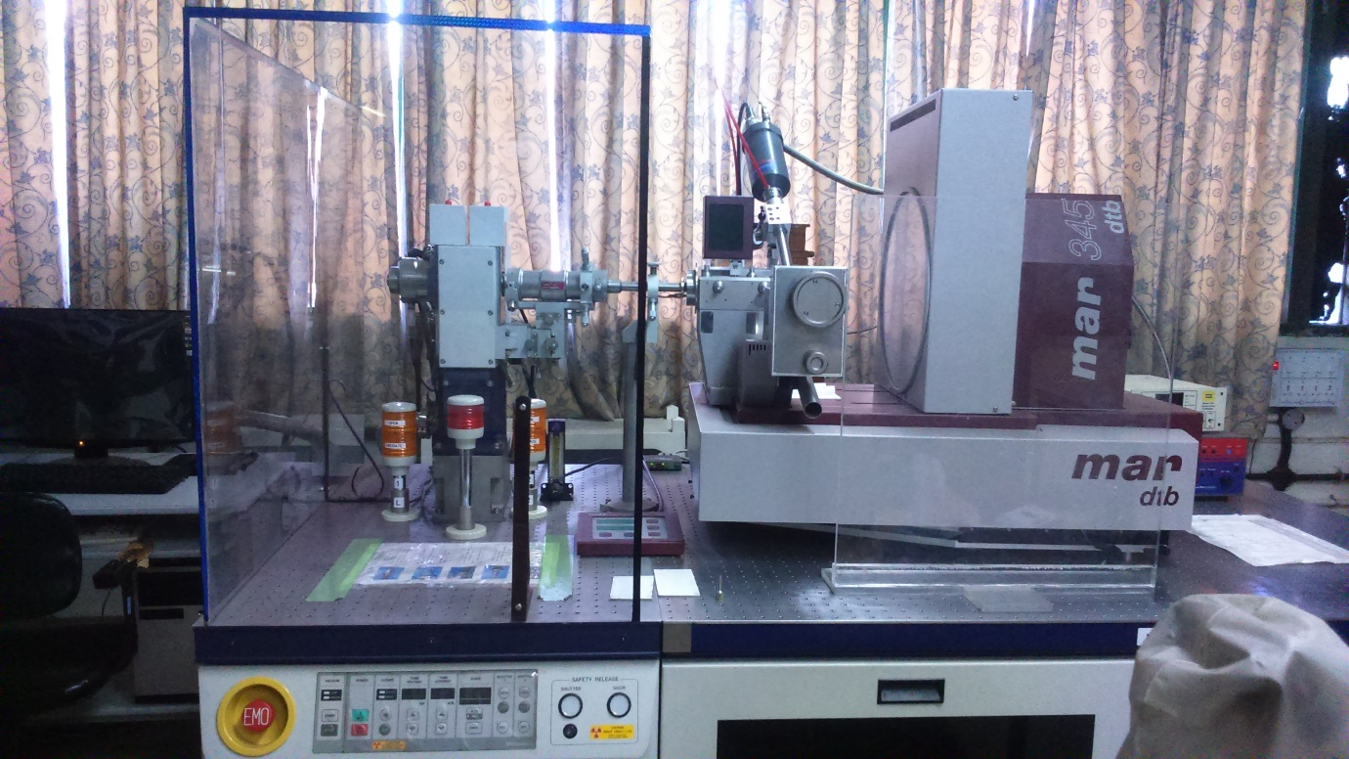
The Macromolecular Crystallography unit comprised of Micro-007 HF is tabletop rotating anode X-ray generator for protein crystallography. The unit is equipped with mar345 DTB image plate detector and Oxford Cryosystem suitable for modern X-ray structure work. The mar345 Image Plate Detector System offers the best choice for recording diffraction patterns of protein crystals.
Specifications:
Image plate detector:
Plate Diameter: 345 mm
Usable detector area: 93.480 mm²
Diameter of scanned area: Software selectable: 180, 240, 300 or 345mm
Pixel size (selectable by software): 150 µm² or 100 µm²
X-ray Generator:
- Maximum power: 1.2 kW
- Voltage: 20 – 40 kV
- Current: 10 – 30 mA
- HV stability: ±0.015
- Available target: Cu Kα-1.5418Å
- X-ray window: 0.2 mm thick beryllium
- Filament: W, annealed and pre-aligned
- Focal spot size: φ = 70μm
- Beam size at sample: 100μm

Accessories:
  - Varimax – HF Confocal optical system.
  - Haskris refrigerated heat exchanger.
  - Oxford Cyrosystems Cryostream Unit (700 Series)
  - AD 51 dry air unit.
  - Lion drier unit.

